june 2024

Popular mortgage   
Digital Prequalification letter

business requirements document (BRD)

Contents

**I. INTRODUCTION** 2

**II. BUSINESS OBJECTIVES AND PROJECT SCOPE** 2

A. Business Objectives 2

B. Project Scope 3

**III. ASSUMPTIONS AND CONSTRAINTS (WIP)** 3

**IV. HIGH-LEVEL FUNCTIONAL REQUIREMENTS** 3

A. General Pre-qualification Engine Process (Proposed) 3

B. Pre-qualification Engine: Form (Fields) 11

C. Pre-qualification Engine: Calculator 18

D. Lightning App for Backoffice 26

E. Challenges 26

F. Development Guidelines 26

G. Reference Docs 26

H. Operational / Functional Requirements: User Stories 27

**V. PROJECT PLAN, SCHEDULE & WHO?, WHAT?, WHEN? (WWW)** 27

**VI. MEETING MINUTES & AGREEMENTS** 27

# **I. INTRODUCTION**

This Business Requirement Document (BRD) outlines the business requirements for a digital pre-qualification letter engine that will enable customers to obtain a pre-qualification letter for a Popular Mortgage’s (PM) loan online through our website, popularMortgage.com. This pre-qualification letter is a preliminary estimate of the loan amount for which the customer could be eligible, based on unverified income and debt information currently provided verbally by the customer during the initial orientation process. The prequalification has a defined validity of 30 days, subject to the conditions stipulated in it. The proposed pre-qualification letter engine will allow customers to input their personal and financial information to receive a customized digital letter that indicates the loan type, loan amount, monthly payment, and other information and terms they are pre-qualified for, considering weekly offers, available products / loan types, among other characteristics and considerations.

**Actual Pre-qualification Letter Process in Encompass (ENCO)**

The actual process of prequalification only considers the income/debt ratio based on the information provided verbally by the customer. To consider other factors and be evaluated for a credit approval, the customer must complete a loan application, provide the required documentation of income, debt, and assets, and comply with all the credit and collateral requirements established by the guarantor agencies, investors, and the credit policy of Popular Mortgage, including, but not limited to, appraisal, title study and tax information of the property.

In the current pre-qualification process, a PM representative, including a Call Center Agent, a Mortgage Assistant (MA), and/or a Senior Mortgage Consultant will provide information and support the customer to understand, and potentially select a mortgage solution/product. If the customer requests a pre-qualification letter, the PM representative will document in Encompass (ENCO) the information provided. Using the current Encompass pre-qualification engine, depending on the financial information and other required fields, the system will provide a decision regarding eligibility. If eligible, the PM representative will proceed to generate the letter and send it to the customer. If not eligible, the representative will provide additional information to either, evaluate other products and/or options.

# **II. BUSINESS OBJECTIVES AND PROJECT SCOPE**

## A. Business Objectives

The main objectives of the proposed pre-qualification letter engine are to:

* Provide customers with a convenient and fast way to obtain a pre-qualification letter for a mortgage loan online.
* Increase customer satisfaction and loyalty by offering a lean and agile service.
* Enhance the company's competitive advantage and market share by attracting more customers and generating more leads.

## B. Project Scope

The scope of the pre-qualification letter engine includes the following features and functions:

* A web-based user interface that allows customers to enter their personal and financial information to receive a pre-qualification letter.
* A mortgage loan pre-qualification eligibility system that uses predefined criteria and algorithms to determine the loan amount and terms the customer is pre-qualified for.
* A letter generation system that creates a customized and branded pre-qualification letter based on the customer's information and loan eligibility.
* An API or integration process to record, automatically, the pre-qualification letter document and related customer information to document lead, preferably in Salesforce/Encompass.
* Generate pre-filled forms for the user interface to identify sources or gather referral information from Mortgage Assistants and/or Senior Mortgage Consultants.

# **III. ASSUMPTIONS AND CONSTRAINTS (WIP)**

The following assumptions and constraints apply to the pre-qualification letter engine:

* The pre-qualification letter engine will integrate with existing systems and platforms, such as the company's website and/or Salesforce CRM.
* The pre-qualification letter engine will be available 24/7 and support multiple browsers and devices.
* The pre-qualification letter engine will have a user-friendly and intuitive design that follows the company's branding and style guidelines.
* The pre-qualification letter engine will be scalable and flexible to accommodate future changes and enhancements.

# **IV. HIGH-LEVEL FUNCTIONAL REQUIREMENTS**

## A. General Pre-qualification Engine Process (Proposed)

**Step 0:** If the customer starts his process with a Sales Rep guiding him thru a process and he needs a prequalification letter and for some reason the Sales Rep can’t prepare it at the moment the Sales Rep will provide a Sales Rep unique web page link, so the customer can complete it.

* It’s the same web form that is described throughout this document but the webpage link is unique for each Sales Rep. Tip: <https://www.popular.com/en/lead/mortgages/consultant=SalesRepName>
* Once the customer submits the form the API or integration process will record Sales Rep Name from the link and mapped it to the Salesforce lead management consultant field.
* If the customer doesn’t start with a Sales Rep then a unique link won’t be necessary.

**Step 1:** Customer fills out an online form with personal and financial information in popularMortgage.com.

* The customer will have the option to select the preferred language for the prequalification form and the prequalification letter, if generated. Also, any message or page generated by the engine will consider the language previously selected.
* The customer will have the opportunity to select what type of transaction, purchase or refinance, is interested in.
  + If the customer selects **Refinance**, the prequalification form will only provide contact information fields.

**

* + If the customer selects **Purchase,** the prequalification form will require contact information, property information, financial information and, if applicable, co-applicant contact and financial information.

**Example 2. Purchase - Prequalification Form (Spanish version)**

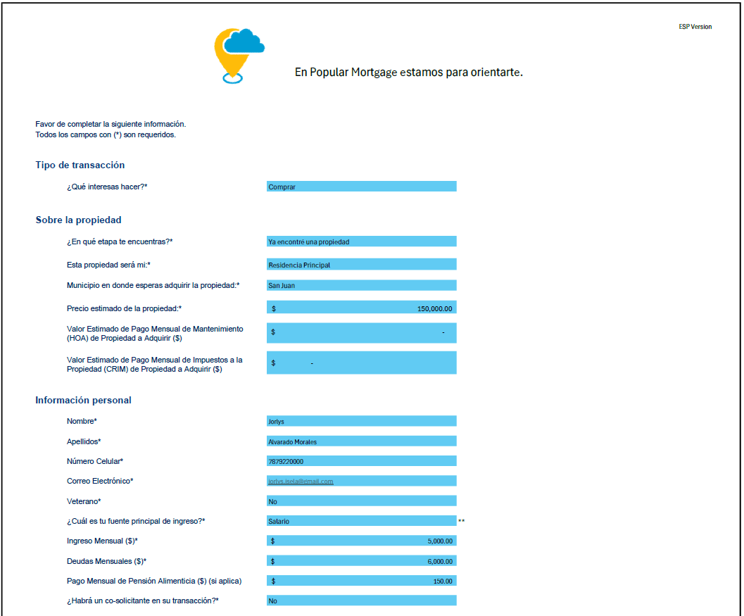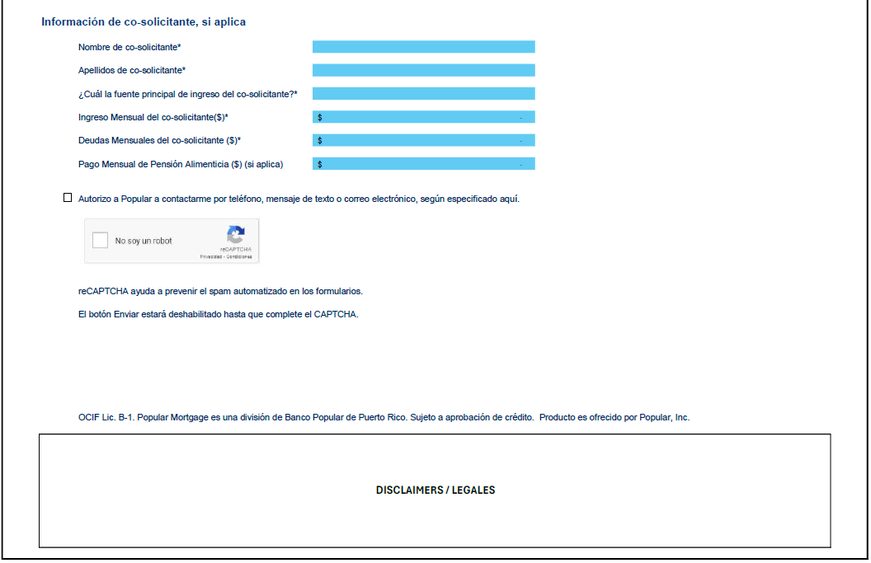

**Screen Tip:** Solo debes considerar las deudas que aparezcan en tu informe de crédito como: mensualidades de otras hipotecas, prestamos, tarjetas de crédito, etc.

**Screen Tip:** Esta precalificación solo tomará en consideración hasta 1 co-solicitante. De tener más co-solicitantes te puedes comunicar con nosotros al 787-000-000

**Notes:**

* These forms might include information (tips) to support the user fill the information as accurately as possible.
* Additional disclaimers and details will be included in this form as required by the engine, business and/or compliance.
* For **Example 1**, some fields and values might be modified depending on the final engine (calculations).
* The branding and final message might change. This example is for position only.
* For reference: Actual contact form in popularMortgage.com: [Hipotecas (popular.com)](https://www.popular.com/formulario/hipotecas/)

**Step 2:** Customer submits the form and receives an instant message indicating the information has been received and contact information for reference.

* The type of message will be generated depending on the type of transaction and the prequalification decision / pre-qualification status.
  + If the customer selected **Refinance**, after completing the required contact information and submitting the form (clicked on Submit button), the following message will be generated in the screen/page.

**Example 3. Refinance form submission confirmation (Spanish Version)**

**Notes:**

* The message will be generated in the preferred language previously selected by the customer.
* The branding and final message might change. This example is for position only.
* This page might include other links and information, as required.
  + If the customer selected **Purchase**, after completing the required contact information and submitting the form (clicked on Submit button), the following message will be generated in the screen/page, depending on the prequalification status.
    - Prequalification Status: **Prequalified** 
      * In this scenario, with the information provided, after the engine evaluation (calculations), a prequalification letter can be generated for the customer (ratios evaluation).

**Example 4. Purchase form submission confirmation with prequalification letter (Spanish Version)**

Gracias por compartirnos su información. La hemos evaluados y estas precalificado para un préstamo hasta [max de cantidad del préstamo]. Próximamente recibirás un correo electrónico con el detalle de los tipos de préstamo y los pagos mensuales correspondientes

Para conocer más opciones para su solicitud puede comunicarse con unos de nuestros representantes de servicio al 787-000-000 de lunes a viernes, de 8:00am-5:00pm

**Notes:**

* The message will be generated in the preferred language previously selected by the customer.
* The branding and final message might change. This example is for position only.
* This page might include other links and information, as required.
  + - Prequalification Status: **Not** **Prequalified** 
      * In this scenario, with the information provided, after the engine evaluation (calculations), a prequalification letter **cannot** be generated for the customer (ratios evaluation).

**Example 5. Purchase form submission confirmation without prequalification letter (Spanish Version)**

**Notes:**

* The message will be generated in the preferred language previously selected by the customer.
* The branding and final message might change. This example is for position only.
* This page might include other links and information, as required.

**Step 3:** If **pre-qualified**, the customer will download or receive via email a personalized pre-qualification letter as a PDF file.

* The email message, and the prequalification letter, will be generated in the preferred language previously selected by the customer.
* The email message will be provided and, if possible, will include branding, links, among other elements, as required.
* The prequalification letter will have customizable/personalized fields. In the following example, these proposed fields will be marked in light blue, for technical reference.
* The letter will require a reference number (automatically generated) that will be printed in the letter and included, automatically, as part of the lead record (customer) fields.

**Example 6. Pre-qualification Letter (PDF) – (English Version)**

**Note:**

* If not pre-qualified, the system will show a message stating that with the provided information we were not able to generate a letter at that time and provide contact information to reach out to evaluate other options, services, and/or products. Also, in Salesforce, a report could be generated with a pipeline to contact those customers.
* This document must generate a control number to identify the letter. This number or identifier must be included in the document and included in the lead record to facilitate searching and reporting on these letters.

**Step 4:** Backend: The document and customer information will be documented in Salesforce (CRM platform) and/or Encompass.

* Submitted forms will generate, automatically, a lead record in CRM Salesforce under the **Record Type = Mortgage**.
* Submitted forms that resulted in a prequalification letter, will require generating a copy of the document sent to the customer in the lead record > Notes/Attachments or Files.
* Reports and dashboards will be defined to support on:
  + Following up on customers that submitted a form by transaction type, prequalification status, and the customer’s stage (if a property has been selected or not yet).
  + Monitor and control duplicated records (leads and referrals object).

## B. Pre-qualification Engine: Form (Fields)

**Table 1. Pre-qualification Form: Fields descriptions, types, and validations**

|  |  |  |  |  |  |
| --- | --- | --- | --- | --- | --- |
| Information Type | Field Name / Question | Required Field? (Y/N) | Field Type | Field Values | Validations |
| Transaction / Loan Information | English: Transaction Purpose  Spanish: Propósito de la Transacción | Y | Picklist | English: 1. Purchase 2. Refinancing  Spanish:  1. Compraventa 2. Refinanciamiento | 1. If the prospect selects the Purchase option, the form continues with the question about the customer's stage. 2. If the prospect selects the Refinancing option, the form should continue requesting contact information, starting with the Name, and ending with the privacy policy information and indicating that they would be communicating with him to continue with the orientation process with a Popular Mortgage representative (Call Center Agent, Mortgage Consultant Assistant and Senior Mortgage Consultant. |
| Transaction / Loan Information | English: What stage are you at?  Spanish: ¿En qué etapa te encuentras? | Y | Picklist | English: 1. I have already found a property  2. I am looking for a property  Spanish: 1. Ya encontré una propiedad. 2. Estoy en búsqueda de una propiedad. | 1. If the prospect (lead) marks the option of "I have already found a property", the form must generate a message inviting the user to fill in the contact information so that they can communicate with him as soon as possible. |
| Property Information | English: Purchase Price  Spanish: Precio estimado de la propiedad | Y | Text | N/A | N/A |
| Property Information | English:  Property Municipality  Spanish:  Municipio donde espera comprar la propiedad | Y | Picklist | Values: List of Municipalities in PR | N/A |
| Property Information | English: This property Will be my:  Spanish: Esta propiedad será para mí: | Y | Picklist | English: 1. Primary Home  2. Secondary Home  3. Investment Property  Spanish: 1. Residencia Principal 2. Segunda Residencia  3. Residencia de Inversión | 1. If the prospect (lead) marks the option of "I have already found a property", the form must generate a message inviting the user to fill in the contact information so that they can communicate with him as soon as possible. |
| Personal Information | English: Name  Spanish: Nombre | Y | Text | N/A | N/A |
| Personal Information | English: Last Name  Spanish: Apellidos | Y | Text | N/A | N/A |
| Personal Information | English: Phone  Spanish: Teléfono | Y | Text | N/A | N/A |
| Personal Information | English: E-mail  Spanish: Correo Electrónico | Y | Text | N/A | N/A |
| Personal Information | English: Veteran  Spanish: Veterano | Y | Picklist | English: 1. Yes.  2. No.  Spanish: 1. Sí 2. No | N/A |
| Personal Information | English: What is your main source of income?  Spanish: ¿Cuál es tu fuente principal de ingreso? | Y | Picklist | English: 1. Salary  2. Professional Services or Self-Employment  3. Pension  Spanish: 1. Salario 2. Servicios Profesionales o Trabajo por Cuenta Propia  3. Pensionado | N/A |
| Personal Information | English: Monthly Income ($)  Spanish: Ingreso Mensual ($) | Y | Amount | N/A | N/A |
| Personal Information | English: Monthly Debts ($)  Spanish: Deudas Mensuales ($) | Y | Amount | N/A | N/A |
| Personal Information | English: Monthly Alimony Payment ($)  Spanish: Pago Mensual de Pensión Alimenticia ($) | Y | Amount | N/A | If the applicant does not pay alimony, the field must require that they enter the amount of $0.00 |
| Transaction / Loan Information | English: Will there be a co-applicant in your transaction?  Spanish: ¿Habrá un co-solicitante en su transacción? | Y | Picklist | English: 1. Yes.  2. No.  Spanish: 1. Sí 2. No | 1. If the prospect (lead) selects the Yes option, the following additional questions must be generated; i. Co-applicant's name ii. Co-applicant's surnames 2. If the prospect (lead) selects the No option, proceed to the next question. |
| Transaction / Loan Information | English: Co-applicant's name  Spanish: Nombre del co-solicitante | Y | Text | N/A | N/A |
| Transaction / Loan Information | English: Co-applicant's last name  Spanish: Apellidos del co-solicitante | Y | Text | N/A | N/A |
| Co-Applicant Personal Information | English: What is the co-applicant's main source of income?  Spanish: ¿Cuál es la fuente principal de ingreso del co-solicitante? | Y | Picklist | English: 1. Salary  2. Professional Services or Self-Employment  Spanish: 1. Salario 2. Servicios Profesionales o Trabajo por Cuenta Propia | N/A |
| Co-Applicant Personal Information | English: Co-Applicant's Monthly Income ($)  Spanish: Ingreso Mensual del Co-Solicitante ($) | Y | Amount | N/A | 1. If there is a co-applicant participating in the transaction, the question must be generated. |
| Co-Applicant Personal Information | English: Co-Applicant's Monthly Debts ($)  Spanish: Deudas Mensuales del Co-Solicitante ($) | Y | Amount | N/A | 1. If there is a co-applicant participating in the transaction, the question must be generated. |
| Co-Applicant Personal Information | English: Co-Applicant's Monthly Alimony Payment ($)  Spanish: Pago Mensual de Pensión Alimenticia ($) | Y | Amount | N/A | If the co-applicant does not pay alimony, the field must require that they enter the amount of $0.00 |
| Property Information | English: Optional: Estimated Property Maintenance Monthly Payment ($)  Spanish: Opcional: Valor Estimado de Pago Mensual de Mantenimiento de Propiedad a Adquirir ($) | N | Amount | N/A | This field would be optional since not all applicants, at this stage, have a selected property. It would be generated if the customer marks that they already have a selected property. |
| Property Information | English: Estimated Property Taxes (CRIM) Monthly Payment ($)  Spanish: Opcional: Valor Estimado de Pago Mensual de Impuestos a la Propiedad (CRIM) de Propiedad a Adquirir ($) | N | Amount | N/A | This field would be optional since not all applicants, at this stage, have a selected property. It would be generated if the customer marks that they already have a selected property. |

## C. Pre-qualification Engine: Calculator

The online pre-qualification engine/calculator is designed to assist prospective home buyers in approximating their loan eligibility and loan mortgage options by evaluating their income and liabilities. It incorporates predefined data such as weekly offers (interest rates), loan terms, and loan-to-value (LTV) and debt-to-income (DTI) ratios, among other related information (data).

For this proposed engine/calculator requirements, please, refer to the following classifications:

* **Input (IN)** = Information or value that the user fills in the pre-qualification form to calculate their loan eligibility and options, including monthly income, liabilities, expected loan amount, etc.
* **Predetermined Data (PD)** = Information or value that the calculator has stored in its system based on Popular Mortgage’s (PM) criteria and product’s conditions, including maximum loan-to-value (LTV) ratio, maximum loan amount, interest rates, etc. The calculator will use this data to determine the user's eligibility and options for the loan, but the user will not be able to change or modify this data.
* **Output (OUT)** = Information or value that the calculator will display in the digital prequalification letter, based on the user’s inputs and the calculation logic, including loan eligibility, interest rate, total monthly payment, etc.
* **Formula (F)** =Information generated by the calculator logic that could be stored or displayed in the pre-qualification letter.

The pre-qualification engine will consist of the following inputs, predetermined data and outputs:

**Table 2. Pre-qualification Engine: Calculator Data/Values by Classification**

|  |  |  |  |  |
| --- | --- | --- | --- | --- |
| Data Classification | Field / Value Name | Definition | Field Type | Source |
| PD / OUT | Loan Type | For this engine, the three (3) available products (loan types) will be **FHA Prime Fixed 30** (**FHA**), **Conventional** (**Freddie Mac**) and **Veteran** (**VA**1).  **Notes:**  (1) The **Veteran** (**VA**) loan type will only apply to users that will select Yes (Y) in the prequalification form field **[Veteran = Y]**. | Text | Calculator Logic: Business Rule |
| IN | This property Will be my: | This value will evaluate if it is possible to provide FHA as a possible option for the user.  IF [**This property Will be my**] = **Primary Home,**  THEN FHA will be an available option for prequalification evaluation/calculation,  ELSE Do not evaluate for FHA.  This constraint could be applied before or after the pre-qualification calculations. However, it is critical that the pre-qualification letter do not include this option even if the applicant(s) and product ratios evaluation results were successful (PASS). | Text | Pre-qualification Form |
| PD / OUT | Interest Rate | The value of the interest rate will fluctuate based on the current offers, which are updated weekly, according to the type of loan and its loan term.  For this field, it is required that the system includes a feature enabling a PM representative to perform weekly updates of these values. | Percentage (%) | Calculator Logic: Business Unit (PM Representative) |
| PD / OUT | Loan Term (Months) | The loan term will be fixed to 30 years or 360 months. | (Months) | Calculator Logic: Business Rule |
| IN | Applicant’s Monthly Income ($) | Applicant’s monthly income depending on the source. | Amount ($) | Pre-qualification Form: Required Field |
| IN | Co-applicant’s Monthly Income ($) | Co-applicant’s monthly income depending on the source. | Amount ($) | Pre-qualification Form: Required Field if Co-applicant Field = Yes (Y) |
| IN | Applicant’s Monthly Debts ($) | Applicant’s monthly liabilities. | Amount ($) | Pre-qualification Form: Required Field |
| IN | Applicant's Monthly Alimony Payment ($) | Applicant's monthly alimony payment, if applicable. | Amount ($) | Pre-qualification Form: Required Field |
| IN | Co-applicant’s Monthly Debts ($) | Co-applicant’s monthly liabilities. | Amount ($) | Pre-qualification Form: Required Field if Co-applicant Field = Yes (Y) |
| IN | Co-Applicant's Monthly Alimony Payment ($) | Co-applicant’s monthly alimony payment, if applicable. | Amount ($) | Pre-qualification Form: Required Field if Co-applicant Field = Yes (Y) |
| F | Total Monthly Income Amount ($) | This value will consider the applicant and co-applicant, if applicable, monthly incomes filled in the digital prequalification form.  Formula: [**Applicant’s Monthly Income ($)**] + [**Co-applicant’s Monthly Income ($)**]  Notes:  (a) In the prequalification form, the co-applicant’s fields could be $0 or Null, if not applicable. | Amount ($) | Calculator Logic: Formula |
| F | Total Monthly Liabilities Amount ($) | This value will consider the applicant and co-applicant, if applicable, monthly incomes filled in the digital prequalification form.  Formula: [**Applicant’s Monthly Debts ($)**] + [**Applicant's Monthly Alimony Payment ($)**] + [**Co-applicant’s Monthly Debts ($)**] + [**Co-Applicant's Monthly Alimony Payment ($)**]  Notes:  (a) In the pre-qualification form, the co-applicant’s fields, and applicant’s and co-applicant’s monthly alimony payment field could be $0 or Null, if not applicable. | Amount ($) | Calculator Logic: Formula |
| IN | Sales Price ($) | Property sales price amount ($). | Amount ($) | Prequalification Form |
| PD | Product Loan to Value (LTV) Percentage (%) | Loan to value (LTV) is a measure comparing the loan amount to the property's total value, in this case, the Sales Price ($) as indicated in the prequalification form.  This value will vary depending on the loan type, property location (municipality), and others.  For this field, it is required that the system includes a feature enabling a PM representative to perform updates of these values. | Percentage (%) | Calculator Logic: Business Unit (PM Representative) |
| F | Base Loan Amount ($) | The base loan amount represents the estimated initial amount that the borrower could be eligible for excluding additional fees that might apply depending on the product (loan type).  Formula: [**Sales Price ($)**]*[**Product Loan to Value (LTV) Percentage (%)**] | Amount ($) | Calculator Logic: Formula |
| PD | Product Loan Amount Limit ($) | This loan amount ($) limit will apply to **loan type = FHA, Conventional (Freddie Mac**).  For this field, it is required that the system includes a feature enabling a PM representative to perform updates of these values. | Amount ($) | Calculator Logic: Business Unit (PM Representative) |
| PD | Upfront Mortgage Insurance (MI) Percentage (%) | The Upfront Mortgage Insurance (MI) is a percentage of the loan amount that is paid upfront during the purchase transaction. This value (percentage) is only applicable for the **loan type = FHA**.  It is required that the system includes a feature enabling a PM representative to perform updates of these values, if needed. | Percentage (%) | Calculator Logic: Business Unit (PM Representative) |
| F | Upfront Mortgage Insurance (MI) Amount ($) | This value (amount) is only applicable for the **loan type = FHA**.  Formula:  IF [**Base Loan Amount ($)**] > [**Product Loan Amount Limit ($)**]  THEN  [**Product Loan Amount Limit ($)**]*[**Upfront MI (%)**]  ELSE  [**Base Loan Amount ($)**]*[**Upfront MI (%)**]  END | Amount ($) | Calculator Logic: Formula |
| PD | VA Guarantee Fee Percentage (%) | This value (amount) is only applicable for the **loan type = VA**.  It is required that the system includes a feature enabling a PM representative to perform updates of these values, if needed. | Percentage (%) | Calculator Logic: Business Unit (PM Representative) |
| F | VA Guarantee Fee Amount ($) | This value (amount) is only applicable for the **loan type = VA**.  Formula:  [**Base Loan Amount ($)**]*[**VA Guarantee Fee Percentage (%)**] | Amount ($) | Calculator Logic: Formula |
| F / OUT | Total Loan Amount ($) **(VA)** | This value (amount) is only applicable for the **loan type = VA**.  Formula:  [**Base Loan Amount ($)**] + [**VA Guarantee Fee Amount ($)**] | Amount ($) | Calculator Logic: Formula |
| F / OUT | Total Loan Amount ($) **(FHA)** | This value (amount) is only applicable for the **loan type = FHA**.  Formula:  IF [**Base Loan Amount ($)**] > [**Product Loan Amount Limit ($)**]  THEN  [**Product Loan Amount Limit ($)**] + [**Upfront Mortgage Insurance (MI) Amount ($)**]  ELSE  [**Base Loan Amount ($)**] + [**Upfront Mortgage Insurance (MI) Amount ($)**]  END | Amount ($) | Calculator Logic: Formula |
| F / OUT | Total Loan Amount ($) **(CONV)** | This value (amount) is only applicable for the **loan type = CONV (Freddie Mac)**.  Formula:  IF [**Base Loan Amount ($)**] > [**Product Loan Amount Limit ($)**]  THEN  [**Product Loan Amount Limit ($)**]  ELSE  [**Base Loan Amount ($)**]  END | Amount ($) | Calculator Logic: Formula |
| F / OUT | Monthly Principal & Interest (P&I) Amount ($) | Formula: **PMT (rate, nper, pv, [fv], [type])1**  Rate = [**Interest Rate (%)**] / 12  Nper = [**Loan** **Term (months)**]  Pv= [**Total Loan Amount ($)**]  Notes:  (1) This is an MS Excel formula: [Pmt Function - Microsoft Support](https://support.microsoft.com/en-us/office/pmt-function-8a27a1b8-ee4a-4dc2-820e-be0cf6c74a37) | Amount ($) | Calculator Logic: Formula |
| PD | Annual Mortgage Insurance (MI) Percentage (%): | The value of the Monthly Mortgage Insurance (MI) percentage (%) will be updated according to the type of loan. This value (percentage) is only applicable for the **loan type = FHA**.  IF [**Product Loan to Value (%)**] > **0.0095**  THEN [**Mortgage Insurance (MI) Percentage (%)**] = **0.0055**  ELSE [**Mortgage Insurance (MI) Percentage (%)**] = **0.0050**  END  For this field, it is required that the system includes a feature enabling a PM representative to perform updates of these values, if needed. | Percentage (%) | Calculator Logic: Business Unit (PM Representative) |
| F | Monthly Mortgage Insurance (MI) Amount ($) | The value of the Monthly Mortgage Insurance (MI) will fluctuate based on the current MI percentage ($) which could be updated according to the type of loan. In this scenario, this fee will only apply to the **FHA loan type.**  Formula: Excel Document > Tab: FHA Monthly MI | Amount ($) | Calculator Logic: Formula |
| PD | Annual Hazard Insurance Percentage (%) | The value is an estimate that will be updated, as needed.  Current value is 0.25%.  For this field, it is required that the system includes a feature enabling a PM representative to perform updates of these values. |  | Calculator Logic: Business Unit (PM Representative) |
| F | Monthly Hazard Insurance Payment ($) | Formula: Formula: [**Sales Price** **Amount ($)**]*{[**Annual Hazard Insurance Percentage (%)]/12**} | Amount ($) | Calculator Logic: Formula |
| IN | Estimated Property Tax (CRIM) Monthly Payment ($) | Optional field in the prequalification form. | Amount ($) | Pre-qualification Form |
| IN | Estimated Property Maintenance (HOA) Payment ($) | Optional field in the prequalification form. | Amount ($) | Pre-qualification Form |
| F | Total Monthly Payment Amount ($) **(FHA)** | This value (amount) is only applicable for the **loan type = FHA**.  This value represents the total monthly payment expected considering the Monthly P&I Amount ($), and other costs related to the mortgage loan. For example, mortgage insurance, HOA, property taxes, and others.  Formula: [**Monthly Principal & Interest (P&I) Amount ($)**] + [**Monthly Mortgage Insurance (MI) Amount ($)**] + [**HOA Amount ($)**] + [**Monthly Property Tax (CRIM) Payment ($)**] + [**Monthly Hazard Insurance Payment** **($)]** | Amount ($) | Calculator Logic: Formula |
| F | Total Monthly Payment Amount ($) **(VA)** | This value (amount) is only applicable for the **loan type = VA**.  This value represents the total monthly payment expected considering the Monthly P&I Amount ($), and other costs related to the mortgage loan. For example, mortgage insurance, HOA, property taxes, and others.  Formula: [**Monthly Principal & Interest (P&I) Amount ($)**] + [**HOA Amount ($)**] + [**Monthly Property Tax (CRIM) Payment ($)**] + [**Monthly Hazard Insurance Payment ($)**] | Amount ($) | Calculator Logic: Formula |
| F | Total Monthly Payment Amount ($) **(CONV)** | This value (amount) is only applicable for the **loan type = CONV (Freddie Mac)**.  This value represents the total monthly payment expected considering the Monthly P&I Amount ($), and other costs related to the mortgage loan. For example, mortgage insurance, HOA, property taxes, and others.  Formula: [**Monthly Principal & Interest (P&I) Amount ($)**] + [**HOA Amount ($)**] + [**Monthly Property Tax (CRIM) Payment ($)**] + [**Monthly Hazard Insurance Payment ($)**] | Amount ($) | Calculator Logic: Formula |
| F / OUT | Required Down Payment ($) | Formula:  IF Loan type = FHA, CONV (Freddie Mac)  THEN  [**Sales Price ($**)] – [**Total Loan Amount ($)**]  ELSE  “$0.00” | Amount ($) | Calculator Logic: Formula |
| F | Applicant(s) Front-end (Housing) Ratio (%) | Formula = [**Total Monthly Payment Amount ($)**] / [**Total Monthly Income Amount ($)**] | Percentage (%) | Calculator Logic: Formula |
| F | Applicant(s) Back-end (Debts) Ratio (%) | Formula = {[**Total Monthly Payment Amount ($)**] + [**Total Monthly Liabilities Amount ($)**]} / [**Total Monthly Income Amount ($)**] | Percentage (%) | Calculator Logic: Formula |
| PD | Product Front-end (Housing) Ratio Limit (%) | The value of the Product Front-end (Housing) ratio limit will fluctuate and could be updated according to the type of loan.   |  |  | | --- | --- | | **Loan Type** | **Front Ratio (Housing Ration)** | | FHA | 31% | | VA | N/A | | Conventional (Freddie Mac) | 28% |   It is required that the system includes a feature enabling a PM representative to perform updates of these values, if needed. | Percentage (%) | Calculator Logic: Business Unit (PM Representative) |
| PD | Product Back-end (Debts) Ratio Limit (%) | The value of the Product Front-end (Housing) ratio limit will fluctuate and could be updated according to the type of loan.   |  |  | | --- | --- | | **Loan Type** | **Back Ratio (Debts Ratio)** | | FHA | 43% | | VA | 41% | | Conventional (Freddie Mac) | 45% |   It is required that the system includes a feature enabling a PM representative to perform updates of these values, if needed. | Percentage (%) | Calculator Logic: Business Unit (PM Representative) |
| F | Applicant(s) vs. Product Front-end Ratios Result | Formula:  IF [Loan Type] = FHA, Conventional (Freddie Mac)  AND [**Applicant(s) Front-end (Housing) Ratio (%)**] <= [**Product Front-end (Housing) Ratio Limit (%)**]  THEN ‘PASS’  ELSE ‘FAIL’  END | Text | Calculator Logic: Formula |
| F | Applicant(s) vs. Product Back-end Ratios Result | Formula:  IF [Loan Type] = FHA, VA, Conventional  AND [**Applicant(s) Back-end (Debts) Ratio (%)**] <= [**Product Back-end (Debts) Ratio Limit (%)**]  THEN ‘PASS’  ELSE ‘FAIL’  END | Text | Calculator Logic: Formula |
| F | Pre-qualification Status (Pre-qualified / Not Prequalified) | Depending on the ratios evaluation, the applicant(s) will be eligible for a prequalification for at least one product (loan type).  Formula 1:   |  |  | | --- | --- | | IF [Loan Type] = VA  AND [Applicant(s) vs. Product Back-end Ratios Result] = “PASS” | | | THEN |  | | ‘Prequalified’ | | | ELSE |  | | ‘Not Prequalified’ | | | END |  |   Formula 2:   |  |  | | --- | --- | | IF [Loan Type] = FHA, CONV (Freddie Mac) | | | AND [Applicant(s) vs. Product Front-end Ratios Result] = “PASS” | | | AND [Applicant(s) vs. Product Back-end Ratios Result] = “PASS” | | | THEN |  | | ‘Prequalified’ | | | ELSE |  | | ‘Not Prequalified’ | | | END |  | | Text | Calculator Logic: Formula |
| PD / OUT | Annual Percentage Rate (APR) | For this field, it is required that the system includes a feature enabling a PM representative to perform updates of these values. | Percentage (%) | Calculator Logic: Business Unit (PM Representative) |
| WORKFLOW | Pre-qualification Status Triggers and Actions | Decision  IF Status = Prequalified,  Show Message **A**  Create Lead in Salesforce  Send Prequalification Letter  Attach Letter to Lead Record  ELSE  Show Message **B**  Create Lead in Salesforce | N/A | Calculator Logic: Workflow |

## D. Lightning App for Backoffice

**Feature 1**: Monitoring and Notifications

* + Back-Office users need to know when a new lead has been registered by a customer and they need to work on it
  + A **Home Dashboard** is available for user’s daily view of Workflow Status.

**Feature 2:** Lead Management

* + A console Lightning App is created with necessary Tabs: Accounts, Cases, Tasks, Reports, Dashboards, etc.
  + Setup Page Layouts
  + Lightning Page

**Feature 3:** Segregated Security

* + Define and Design **Permission Sets** for **Customer** and **Back-Office** Users

## E. Challenges

Challenges were created to increase the complexity of the project. Below the different challenges with its corresponding category:

* + Develop a solution to minimize the number of duplicate leads. This challenge is highly encouraged.
  + Do research about Salesforce Financial Services and explain if this can simplify the process described in this document
  + The following challenges are considered as nice to have and should only be worked on if enough time is available.
    1. Do research about Salesforce Financial Services and explain if this can simplify the process described in this document
    2. Implement chatbots for customer interaction and initial triage.

## F. Development Guidelines

* Coding Standards: Follow industry best practices and Salesforce development guidelines.
* Version Control: Use a version control system (e.g., Git) for code management.
* Testing: Implement unit tests, integration tests, and user acceptance testing.
* Documentation: Maintain clear and comprehensive documentation of all code and processes.
* Identify Potential Risks: Delays in development, integration challenges, data security issues.

## G. Reference Docs

* The following document has the process flow, web forms and notification details.



* Prequalification Letter Engine / Calculator

[Prequalification_Engine_Workbook](https://bppr-my.sharepoint.com/personal/jorlys_alvaradomorales_popular_com/Documents/Escritorio/Prequalification_Engine_Workbook.xlsm?web=1)

## H. Operational / Functional Requirements: User Stories

**Table 3. Requirements - User Stories**

|  |  |  |  |  |  |
| --- | --- | --- | --- | --- | --- |
| ID | Process | User | User Story | Criticality | Proposed Solution |
| 1 |  |  |  |  |  |
| 2 |  |  |  |  |  |

# **V. PROJECT PLAN, SCHEDULE & WHO?, WHAT?, WHEN? (WWW)**

**Table 4. Project Plan: Tasks, Owners and Status**

|  |  |  |  |  |  |
| --- | --- | --- | --- | --- | --- |
| ID | Project Task | Description | Owner | Status | Date |
| 1 |  |  |  |  |  |
| 2 |  |  |  |  |  |
| 3 |  |  |  |  |  |
| 4 |  |  |  |  |  |

# **VI. MEETING MINUTES & AGREEMENTS**

**Table 5. Meeting Minutes & Action Items**

|  |  |
| --- | --- |
| Meeting Date | Notes & Agreements |
|  |  |